(Approx. 378 words)

Add a Display!
By Dorothy Fitch, Editor, Green Valley Resort Computer Club, AZ
February 2019 issue, Green Bytes
www.ccgvaz.org
Newsletter (at) ccgvaz.org

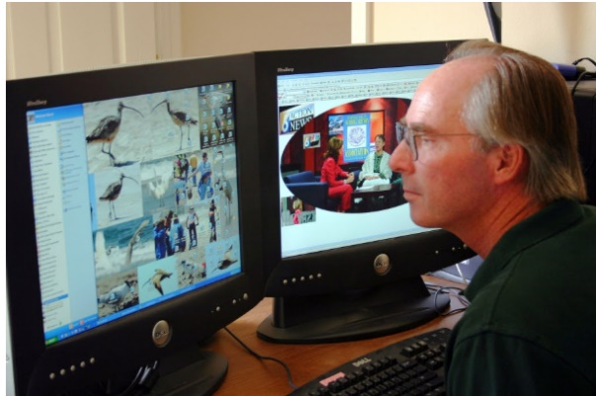

Photo Credit: everystockphoto.com

If you spend a lot of time at your computer, as I do, you might want to consider having two separate monitors. I love my two displays, as it gives me lots of extra digital "real estate" for when I have many windows open. I can use the mouse to drag windows from one monitor to the other. The second monitor can display the task bar and clock at the bottom, and you can even extend images across the two displays or show the same content on both monitors.
On Windows 10, to set up or adjust multiple displays, go to Settings>System>Displays. One monitor will be your primary monitor, and the other the secondary one. You can have a different resolution setting for each monitor. You can also swap the positions of the icons in the Settings area so that when you want to drag a window to the other monitor, you don't have to drag your mouse the opposite way, which is quite counter-intuitive! Click to read about dual monitor setups.
But what do you do when a monitor fails, as my second display did the other day while I was working on this Green Bytes newsletter? The contents of a file open on that monitor started to flicker and then I watched the monitor turn completely black. Oh, my.... There were a number of open windows and documents displayed on that monitor and now I couldn't get to them! What to do? Google to the rescue!
By Googling this text -- see files when second monitor is off -- I found the answer! All I had to do was hold down the Shift key as I right-clicked the icon on the Taskbar for the document I couldn't see. I could choose the 'Move' option from the menu, and then use the right-arrow key on the keyboard to move the window, little by little. Lo and behold, it came into view on my one working monitor.
If you have room on your desk and a second monitor available, you might enjoy having the extra room for all your work (and play).

